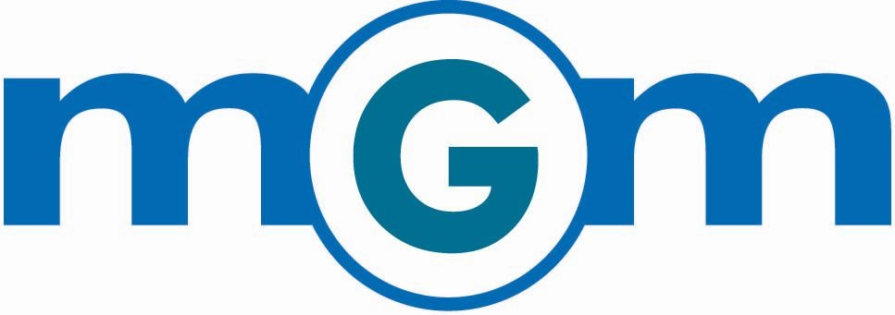

Job Description: Specialty Ingredients Buyer

Position Overview:
MGM is a prominent buyer and seller of food ingredients and products for specialty feed and industrial markets. The diversity of our business allows for success in both strong and weak economies, and we have continued to grow profitably year-over-year since opening in 1992.
Our specialty ingredient buyers are the engine of our mission to provide value to our customers through cost-effective and creative ingredient solutions. Due to business growth, we are seeking to add a highly motivated individual to our dynamic team of buyers.
MGM Environment:
We are a small and mighty group with high employee retention due to our unique work culture, team environment and career development opportunities.
Current team members say this about working at our MGM office in Overland Park, KS:
“This small group can run circles around what gets accomplished at most companies.”
“Mornings in our office are nothing short of electric!”
“Working here has given me so much confidence.”
“The small company environment and close connections have you looking forward to each day in the office.”
“MGM is my career because I have the freedom to pursue areas of interest and am rewarded for success.”
“Travel is not a weekly requirement, allowing employees to attend the majority of their children’s events.”
“Employees receive impactful bonuses based on each year’s success.”

Growth potential is unlimited with MGM. You have autonomy to approach your job like a business owner. Do you desire to be Vice President or President of MGM in the next 5-7 years? MGM is seeking individuals with the capabilities to be the next successors.
Responsibilities in the Buyer Development Program:
In this role, you will embark on a comprehensive development program designed to equip you with the knowledge and skills required for success at MGM including:
Business Development: Begin building your own book of business by networking, prospecting, and engaging in cold calling activities. Qualify potential clients, understand their needs, and present offerings to foster new trading relationships.
Market Analysis: Continuously generate trading ideas by identifying market trends, monitoring market conditions, and spotting opportunities for profitable trades. Stay updated with real-time price discovery to make informed trading decisions.
Client Relationship Management: Develop and nurture relationships with clients, offering valuable market intelligence, and providing insights into ingredient trading. Act as a trusted advisor and establish yourself as a reliable source of information.
Continuous Learning: Maintain up-to-date knowledge of the markets, including factors influencing supply and demand, price fluctuations, and market dynamics. Stay informed about regulatory changes and industry trends.
Risk Management: Collaborate with senior buyers to understand and manage risk exposure effectively. Learn to assess risk and implement appropriate risk mitigation strategies.
Performance Tracking: Track and analyze trading activities, performance metrics, and key market indicators to identify areas for improvement and optimize trading strategies.
Qualifications:
High Energy and Entrepreneurial Spirit: Demonstrate enthusiasm, self-motivation, and a proactive approach to learning and problem-solving. Demonstrate a passion for seizing opportunities, taking calculated risks, making autonomous decisions and driving results.
Relationship Building: Possess excellent interpersonal and communication skills with a willingness to engage in client interactions primarily on the phone and occasionally via email to build strong professional relationships. A charismatic team player who can use direct language and engage actively in brainstorming with logical support. Can give, accept and act on feedback in a respectful manner.
Ambition and Achievement-Oriented: Show a strong desire to succeed, take ownership of responsibilities, and aspire to manage your own trading business. Hungry for a challenge and not afraid to solicit new customers through cold calls, leads or networking around 20% of the time.
Analytical and Mathematical Skills: Exhibit proficiency in problem-solving, critical thinking, and numerical analysis. Comfortable working with complex data sets and conducting quantitative analysis. The ability to visualize the process and application of an ingredient and its consumptive use. Strong attention to detail with a focus on quality.
Adaptability and Fast-Paced Environment: Thrive in a dynamic and fast-paced trading environment where plans are made and executed daily. Ability to make decisions under pressure.
Educational Background: A bachelor's degree in: supply chain management, agriculture, science, engineering, finance, economics, business, or a related field is preferred, but not mandatory. Beneficial, but not required, for the candidate to understand basic chemistry and/or have some livestock nutrition knowledge.

Travel
This position will likely travel 6 to 12 times a year depending on your skill set, the need, and your desire.
Compensation and Benefits
MGM pays a very competitive wage relative to other companies in the industry. Each employee is also rewarded with an annual bonus that is commensurate with the effort, attitude and results they contribute.
MGM offers excellent benefits. MGM pays 100% of employee health insurance premiums and pays 25% of spouse and dependent health insurance premiums. Excellent policy with a low deductible. MGM pays for life insurance and disability insurance to benefit employee. MGM matches the first 6% of a 401K plan and provides additional retirement savings through a company profit-sharing program. Benefits include paid vacation, sick leave, and bereavement.
Join the MGM team and embark on an exciting career journey in the ingredient trading industry. Our comprehensive development program will provide you with the necessary tools and knowledge to succeed in this fast-paced environment. Experience our unique company culture, work alongside industry experts, and contribute to the continued growth and success of MGM. Apply today and be part of our dynamic team.
To apply, please send a cover letter and your resume to Kim Hightower at khightower@teammgm.com

